**CRPTOGRAPHY AND NETWORK SECURITY LAB**

**Index**

|  |  |
| --- | --- |
| **Sr. No.** | **Practical** |
| 1. | Program to implement Caesar Cipher. |
| 2. | Program to implement Mono alphabetic Cipher. |
| 3. | Networking:   1. How to find the OS of the target machine: 2. Daemon grabbing 3. Active fingerprinting 4. ICMP messages 5. Passive fingerprinting 6. To get list of services running on various open ports. 7. How to take the information of system where the IP address of target, subnet mask 8. Traceroute 9. ICMP |
| 4. | Program to implement Transposition Cipher. |
| 5. | Program to implement Hill Cipher. |
| 6. | Program to find the GCD of two polynomials using Euclidean. |
| 7. | Program to find the multiplicative inverse of a number. |
| 8. | Program to implement Play fair Cipher. |
| 9. | Program to implement Rail fence Cipher. |
| 10. | Program to implement simplified AES. |
| 11. | Program to check primality using Miller – Rabin theorem. |
| 12. | Program to solve the equations using Chinese Remainder theorem. |
| 13. | Program to encrypt and decrypt the text using DES. |
| 14. | Program to implement fast exponentiation. |
| 15. | Program to implement RSA algorithm. |
| 16. | Program to implement text cover. |
| 17. | Program to implement random number generator. |
| 18. | Program to implement Discrete algorithm. |
| 19. | Program to implement DSA algorithm. |
| 20. | Program to implement Elgamal DSA. |
| 21. | Program to implement RSA DSA. |
| 22. | Program to implement Diffie Hellman algorithm. |

1. **Program to implement Caesar Cipher.**

**Program:**

#include<stdio.h>

#include<string.h>

void main()

{

FILE *fp;

printf("\nenter the text to be encrypted---->");

fp=fopen("encrypt.txt","w");

char ch;

char str[100];

while((ch=getc(stdin))!='\n')

{

fputc(ch,fp);

}

fclose(fp);

int k;

int i=0;

printf("\nenter key value---->");

scanf("%d",&k);

FILE *f=fopen("encrypt.txt","r");

FILE *d=fopen("decrypt.txt","w");

while((ch=fgetc(f))!=EOF)

{

int val=(int)ch;

if(val>=65&&val<=90)

{

val=val+k;

if(val<65||val>90)

val=(val%91)+65;

}

else

if(val>=97&&val<=122)

{

val=val+k;if(val<97||val>122)

val=(val%123)+97;

}

else

if(val>=48&&val<=57)

{

val=val+k;

if(val<48||val>57)

val=(val%58)+48;

}

ch=(char)val;

str[i++]=ch;

}

str[i]='\0';

printf("\ndecrypted text---->%s\n",str);

}

**Output:**

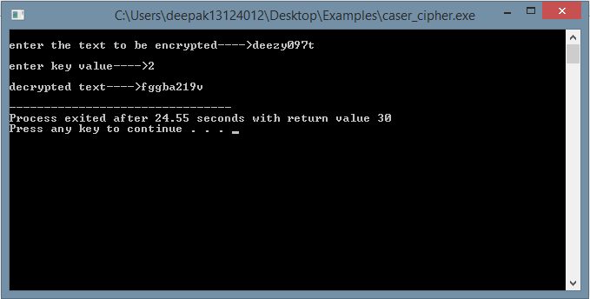

1. **Program to implement Mono alphabetic Cipher.**

**Program:**

#include<iostream>

#include<conio.h>

#include<stdio.h>

#include<string.h>

using namespace std;

void encryption();

void decryption();

char pt[50],ct[50],ch;

char alpha[26]={'a','b','c','d','e','f','g','h','i','j','k','l','m','n','o','p','q','r','s','t','u','v','w','x','y','z'};

char sub[26]= {'q','w','e','r','t','y','u','i','o','p','a','s','d','f','g','h','j','k','l','z','x','c','v','b','n','m'};

int i,j;

int main()

{

int choice;

cout<<"****Monoalphabetic Cipher Technique***";

cout<<"\n\n1. Encryption\n2. Decryption\n3. exit";

while(1)

{

cout<<"\n\nEnter your choice: ";

cin>>choice;

switch(choice)

{

case 1: //Encryption

encryption();

break;

case 2: //Decryption

decryption();

break;

case 3: return 0;

break;

default: //Wrong Input

cout<<"\nIncorrect choice. Try again!!";

break;

}

}

getch();

}

void encryption()

{

cout<<"\n--------Encryption--------";

cout<<"\nEnter text to be encrypted: ";

scanf("%s",pt);

for(i=0;i<strlen(pt);i++)

{

ch = pt[i];

for(j=0;j<26;j++)

{

if(alpha[j]==ch)

{

ct[i]=sub[j];

// break;

}

}

}

ct[i]='\n';

cout<<"\nThe cipher text is: ";

for(i=0;i<strlen(pt);i++)

cout<<ct[i];

cout<<"\n--------------------------";

}

void decryption()

{

cout<<"\n--------Decryption--------";

cout<<"\nEnter text to be decrypted: ";

scanf("%s",ct);

for(i=0;i<strlen(ct);i++)

{

ch=ct[i];

for(j=0;j<26;j++)

{

if(sub[j]==ch)

{

pt[i]=alpha[j];

break;

}

}

}

pt[i]=' ';

cout<<"\nThe plain text is: ";

for(i=0;i<strlen(ct);i++)

cout<<pt[i];

cout<<"\n--------------------------";

}

**Output:**

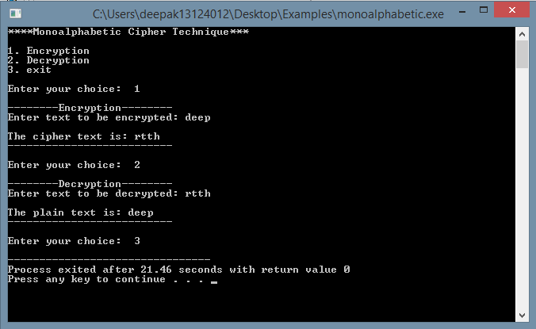

1. **Networking:**
2. **How to find the OS of the target machine:**
3. **Daemon grabbing**
4. **Active fingerprinting**
5. **ICMP messages**
6. **Passive fingerprinting**
7. **To get list of services running on various open ports.**
8. **How to take the information of system where the IP address of target, subnet mask**
9. **Traceroute**
10. **ICMP**

**Output:**

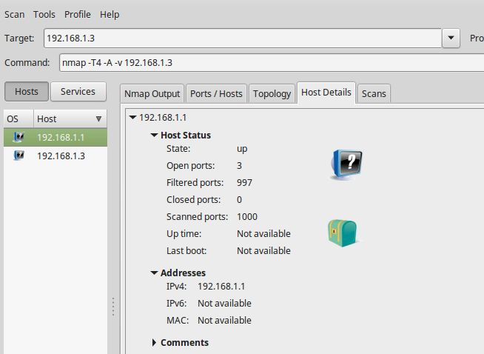

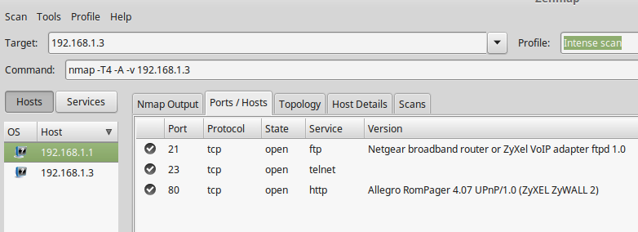

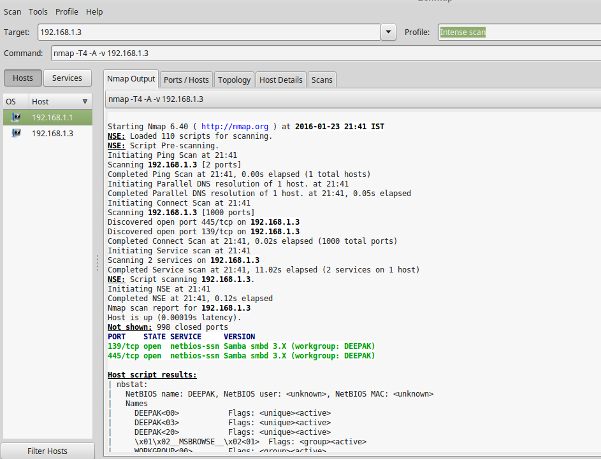

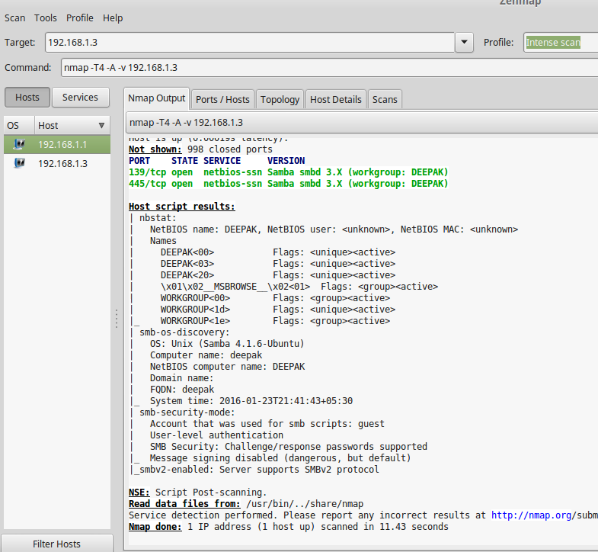

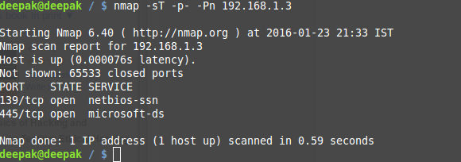

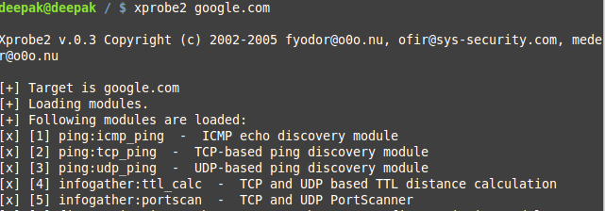

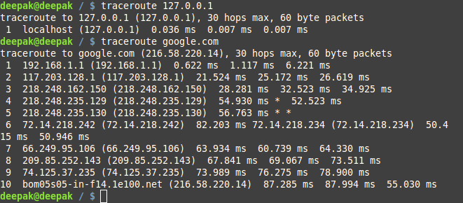

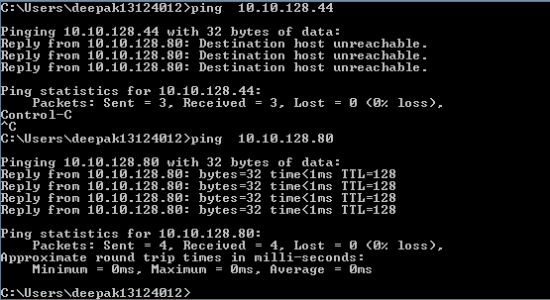

1. **Program to implement Transposition Cipher.**

**Program:**

#include<stdio.h>

#include<string.h>

#include<stdlib.h>

void cipher(int i,int c);

int findMin();

void makeArray(int,int);

char arr[22][22],darr[22][22],emessage[111],retmessage[111],key[55];

char temp[55],temp2[55];

int k=0;

int main() {

char *message,*dmessage;

int i,j,klen,emlen,flag=0;

int r,c,index,min,rows;

FILE *fp;

printf("\nenter the text to be encrypted---->");

fp=fopen("encrypt.txt","w");

char ch;

char str[100];

while((ch=getc(stdin))!='\n')

{

fputc(ch,fp);

}

fclose(fp);

printf("Enetr the key\n");

fflush(stdin);

scanf("%s",key);

FILE *f=fopen("encrypt.txt","r");

i=0;

while((ch=fgetc(f))!=EOF)

{

emessage[i]=ch;

i++;

}

message=&emessage[0];

strcpy(temp,key);

klen=strlen(key);

k=0;

for (i=0; ;i++) {

if(flag==1)

break;

for (j=0;key[j]!='\0';j++) {

if(message[k]=='\0') {

flag=1;

arr[i][j]='-';

} else {

arr[i][j]=message[k++];

}

}

}

r=i;

c=j;

for (i=0;i<r;i++) {

for (j=0;j<c;j++) {

printf("%c ",arr[i][j]);

}

printf("\n");

}

k=0;

for (i=0;i<klen;i++) {

index=findMin();

cipher(index,r);

}

emessage[k]='\0';

printf("\nEncrypted message is\n");

for (i=0;emessage[i]!='\0';i++)

printf("%c",emessage[i]);

printf("\n\n");

//deciphering

emlen=strlen(emessage);

//emlen is length of encrypted message

strcpy(temp,key);

rows=emlen/klen;

//rows is no of row of the array to made from ciphered message

rows;

j=0;

for (i=0,k=1;emessage[i]!='\0';i++,k++) {

//printf("\nEmlen=%d",emlen);

temp2[j++]=emessage[i];

if((k%rows)==0) {

temp2[j]='\0';

index=findMin();

makeArray(index,rows);

j=0;

}

}

printf("\nArray Retrieved is\n");

k=0;

for (i=0;i<r;i++) {

for (j=0;j<c;j++) {

printf("%c ",darr[i][j]);

//retrieving message

retmessage[k++]=darr[i][j];

}

printf("\n");

}

retmessage[k]='\0';

printf("\nMessage retrieved is\n");

for (i=0;retmessage[i]!='\0';i++)

printf("%c",retmessage[i]);

//getch();

return(0);

}

void cipher(int i,int r) {

int j;

for (j=0;j<r;j++) { {

emessage[k++]=arr[j][i];

}

}

// emessage[k]='\0';

}

void makeArray(int col,int row) {

int i,j;

for (i=0;i<row;i++) {

darr[i][col]=temp2[i];

}

}

int findMin() {

int i,j,min,index;

min=temp[0];

index=0;

for (j=0;temp[j]!='\0';j++) {

if(temp[j]<min) {

min=temp[j];

index=j;

}

}

temp[index]=123;

return(index);

}

**Output:**

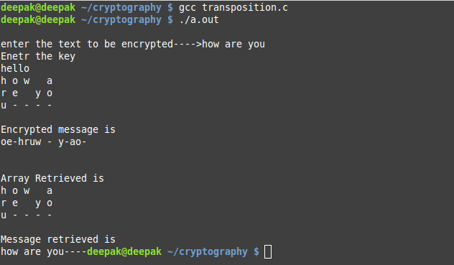

1. **Program to implement Hill Cipher.**

**Program:**

#include<stdio.h>

#include<string.h>

#include<stdlib.h>

int **matrixMultiply(int**a,int r1,int c1,int **b,int r2,int c2)

{

int **resultMatrix;

int i,j,k,r,c;

r=r1;c=c2;

resultMatrix=(int**)malloc(sizeof(int*)*r);

for(i=0;i<r;i++)

resultMatrix[i]=(int*)malloc(sizeof(int)*c);

for(i=0;i<r;i++)

{

for(j=0;j<c;j++)

{

resultMatrix[i][j]=0;

for(k=0;k<c1;k++)

resultMatrix[i][j]+=a[i][k]*b[k][j];

}

}

return resultMatrix;

}

void printMatrix(int**matrix,int r,int c)

{

int i,j;

for(i=0;i<r;i++)

{

for(j=0;j<c;j++)

printf("%d ",matrix[i][j]);

printf("\n");

}

}

int plainTextToCipherText(char plainText[],int**matrix)

{

int len,**plainTextMatrix,**resultMatrix,i,j;

// The matrix will be of dimensions strlen(plainText) by strlen(plainText)

char *cipherText;

len=strlen(plainText);

cipherText=(char*)malloc(sizeof(char)*1000);

// plainTextMatrix should be of dimension strlen(plainText) by 1

// allcating memory to plainTextMatrix

plainTextMatrix=(int**)malloc(sizeof(int*)*len);

for(i=0;i<len;i++)

plainTextMatrix[i]=(int*)malloc(sizeof(int)*1);

// populating the plainTextMatrix

for(i=0;i<len;i++)

for(j=0;j<1;j++)

plainTextMatrix[i][j]=plainText[i]-'a';

resultMatrix=matrixMultiply(matrix,len,len,plainTextMatrix,len,1);

// taking mod 26 of each element of the result matrix

for(i=0;i<len;i++)

for(j=0;j<1;j++)

resultMatrix[i][j]%=26;

// Printing the cipher text

printf("The cipher text is as follows : ");

for(i=0;i<len;i++)

for(j=0;j<1;j++)

printf("%c",resultMatrix[i][j]+'a');

printf("\n");

//printMatrix(resultMatrix,len,1);

}

int main()

{

int len,i,j,**matrix;

char plainText[1000];

printf("Enter the word to be encrypted : ");

scanf(" %s",plainText);

len=strlen(plainText);

// allocating memory to matrix

matrix=(int**)malloc(sizeof(int*)*len);

for(i=0;i<len;i++)

matrix[i]=(int*)malloc(sizeof(int)*len);

printf("Enter the matrix of %d by %d to be used in encryption process : \n",len,len);

for(i=0;i<len;i++)

for(j=0;j<len;j++)

scanf("%d",&matrix[i][j]);

plainTextToCipherText(plainText,matrix);

return 0;}

**Output:**

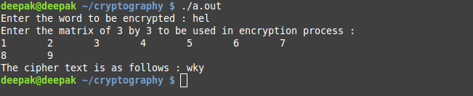

1. **Program to find the GCD of two polynomials using Euclidean.**

**Program:**

#include<stdio.h>

int power(int x,int y){

int i;

int r=1;

for(i=0;i<y;i++){

r=r*x;

}

return r;

}

int sub(int a,int b,int m){

int f=0,s,t,r,k,i;

for(i=1;i<=m;i++){

k=10;

s=a%k;

t=b%k;

a=a/k;

b=b/k;

if(s==t)

r=0;

if(s!=0&&t==0)

r=1;

if(t!=0&&s==0)

r=1;

s=i;

k=power(10,s-1);

f=f+r*k;

}

return f;

}

int bits(int x){

int s=0;

while(x){

x=x/10;

s++;

}

return s;

}

int gcd(int a,int b,int m){

int diff,r,temp,final;

while(bits(a)>=bits(b)){

diff=bits(a)-bits(b);

if(diff>=0)

temp=b*power(10,diff);

r=sub(a,temp,m);

final=a;

a=r;

}

if(a==0) return final;

if(bits(a)<bits(b)) gcd(b,a,m);

}

int makenumber(int a[], int m){

int r=0,i;

int temp=m;

for(i=0;i<m;i++){

temp--;

r=r+a[i]*power(10,temp);

}

return r;

}

void main(){

int i,j,m;

printf("\nenter the highest power of first equation");

scanf("%d",&m);

int arr1[m],arr2[m];

printf("\nenter the coefficients of first equation in decreasing order of power");

printf("starting from coefficient of highest degree %d\n",m);

for(i=0;i<=m;i++){

scanf("%d",&arr1[i]);

}

printf("\nenter the coefficients of second equation in decreasing order of power");

printf("starting from coefficient of highest degree %d\n",m);

for(i=0;i<=m;i++){

scanf("%d",&arr2[i]);

}

printf("\nfirst equation is: ");

for(i=m,j=0;i>=0,j<=m;i--,j++){

if(j!=m) printf("%dx^%d + ",arr1[j],i);

else printf("%d",arr1[j]);

}

printf("\nsecond equation is: ");

for(i=m,j=0;i>=0,j<=m;i--,j++){

if(j!=m) printf("%dx^%d + ",arr2[j],i);

else printf("%d",arr2[j]);

}

int a=makenumber(arr1,m+1);

int b=makenumber(arr2,m+1);

m++;

int r= gcd(a,b,m);

printf("\nGCD: ");

for(i=bits(r)-1;i>=0;i--){

int t=r/power(10,i);

if(i!=0) printf("%dx^%d +",t,i);

else printf("%d\n",t );

r=r%power(10,i);

}

}

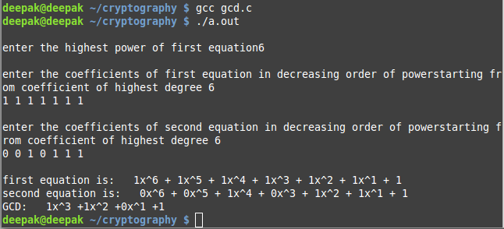**Output:**

1. **Program to find the multiplicative inverse of a number.**

**Program:**

#include <stdio.h>

int modInverse(int a, int m){

int m0 = m, t, q, x0 = 0, x1 = 1;

if (m == 1) return 0;

while (a > 1){

q = a / m;

t = m;

m = a % m, a = t;

t = x0;

x0 = x1 - q * x0;

x1 = t;

}

if (x1 < 0) x1 += m0;

return x1;

}

int main(){

int a,m;

printf("\nenter the value of 'a' and 'm' where 'a' under modulo 'm'");

scanf("%d%d",&a,&m);

printf("Modular multiplicative inverse is %d\n",

modInverse(a, m));

return 0;

}

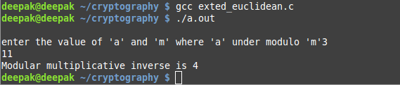**Output:**

1. **Program to implement Play fair Cipher.**

**Program:**

#include <bits/stdc++.h>

using namespace std;

static int substitution_index;

char *mat[8];

void build_matrix(string &s1,char ** mat){

for(int i=0 ; i<8; i++)

mat[i]= new char[8];

for(int i=0; i<8; i++)

for(int j=0; j<8; j++)

mat[i][j]='!';

set<char> unique;

for(int i=0; i<s1.size(); i++)

unique.insert(s1[i]);

set<char>::iterator sit=unique.begin();

int last_row,last_col;

bool over=false;

for(int i=0; i<8; i++){

for(int j=0; j<8; j++)

if (sit!=unique.end()){

mat[i][j]=*sit;

sit++;

}

else{

last_col=j;

last_row=i;

over=true;

break;

}

if (over)break;

}

vector<char>not_added_lower;

for(char x='a'; x<='z'; x++)

if (find(unique.begin(), unique.end(),x)==unique.end())

not_added_lower.push_back(x);

for(int i=0; i<not_added_lower.size(); i++){

if ((last_col)%8==0){

last_row+=1;

last_col=0;

mat[last_row][last_col++]=not_added_lower[i];

}

else mat[last_row][last_col++]=not_added_lower[i];

}

vector<char>not_added_upper;

for(char x='A'; x<='Z'; x++)

if (find(unique.begin(), unique.end(),x)==unique.end())

not_added_upper.push_back(x);

for(int i=0; i<not_added_upper.size(); i++){

if ((last_col)%8==0){

last_row+=1;

last_col=0;

mat[last_row][last_col++]=not_added_upper[i];

}

else mat[last_row][last_col++]=not_added_upper[i];

}

for (int i=0; i<10; i++){

if ((last_col)%8==0){

last_row+=1;

last_col=0;

mat[last_row][last_col++]=i+'0';

}

else mat[last_row][last_col++]=i+'0';

}

cout<<"\n";

for(int i=0; i<8; i++){

for(int j=0; j<8; j++)

cout<<" "<<mat[i][j];

cout<<endl;

}

}

char encrypt(char a,char b,vector<char>& output){

int x1,x2,y1,y2;

for(int i=0; i<8; i++)

for(int j=0; j<8; j++)

if (mat[i][j]==a){

x1=i;

y1=j;

break;

}

for(int i=0; i<8; i++)

for(int j=0; j<8; j++)

if (mat[i][j]==b){

x2=i;

y2=j;

break;

}

if (x1==x2){

output.push_back(mat[x1][(y1+1)%8]);

output.push_back(mat[x2][(y2+1)%8]);

output.push_back(' ');

}

else if (y1==y2){

output.push_back(mat[(x1+1)%8][y1]);

output.push_back(mat[(x2+1)%8][y2]);

output.push_back(' ');

}

else{

output.push_back(mat[x2][y1]);

output.push_back(mat[x1][y2]);

output.push_back(' ');

}

}

void solve(vector<char> & input_1,vector<char> & input_2){

vector<char>:: iterator it = input_1.begin();

vector<char>:: iterator it2 = input_2.begin();

vector<char> output;

cout<<"\n The Decrypted Message: ";

for(;it!=input_1.end();it++,it2++){

cout<<*it<<*it2<<" ";

encrypt(*it,*it2,output);

}

vector<char>:: iterator ot = output.begin();

cout<<"\n The Encrypted Message: ";

for(;ot!=output.end();ot++)

cout<<*ot;

}

int main(){

string s1;

cout<<"\n Enter key string for the matrix: ";

cin >> s1;

build_matrix(s1,mat);

ifstream inf("input.txt");

char c,i1,i2;

vector<char>input_1;

vector<char>input_2;

while((c=inf.get())!=EOF){

if(!isalnum(c))

continue;

i1=c;

i2=inf.get();

while(!isalnum(i2))

i2=inf.get();

if(i1==i2){

input_1.push_back(c);

input_2.push_back('!');

input_2.push_back(c);

input_1.push_back('!');

}

else{

input_1.push_back(i1);

input_2.push_back(i2);

}

}

inf.close();

solve(input_1,input_2);

cout<<endl<<endl;

return 0;

}

**OUTPUT:**

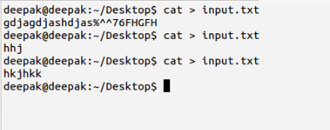

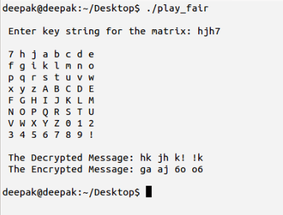

1. **Program to implement Rail fence Cipher.**

**Program:**

#include<stdio.h>

#include<string.h>

#include<ctype.h>

void main(){

int i,j=0,d,k=0;

char p[50],ct[50][50];

printf("Enter the plain text:\n");

fgets(p,sizeof(p),stdin);

printf("\nEnter the depth in the integer:");

scanf("%d",&d);

for(i=0;i<50;i++){

for(j=0;j<50;j++){

ct[i][j]='\0';

}

}

k=0;

{

for(i=0;i<strlen(p);i++){

for(j=0;j<d;j++)

{

if(k<=strlen(p))

ct[i][j]=p[k];

k++;

}

ct[i][j]='\0';

}

}

for(i=0;i<d;i++){

for(j=0;j<strlen(p);j++){

if(ct[j][i]!='\0') {

printf("%c",ct[j][i]);

}

}

printf("\n");

}

printf("\nThe encrypted text is:\n");

for(i=0;i<d;i++)

{

for(j=0;j<strlen(p);j++)

{

if(ct[j][i]!='\0')

printf("%c",ct[j][i]);

}

}

getch();

}

**Output:**

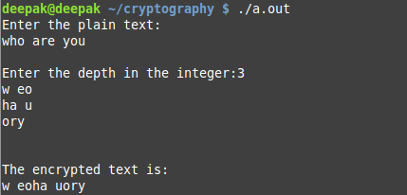

1. **Program to implement simplified AES.**

**Program:**

import javax.swing.*;

import java.security.SecureRandom;

import javax.crypto.Cipher;

import javax.crypto.KeyGenerator;

import javax.crypto.SecretKey;

import javax.crypto.spec.SecretKeySpec;

import java.util.Random ;

class AES {

byte[] skey = new byte[1000];

String skeyString;

static byte[] *raw*;

String inputMessage,encryptedData,decryptedMessage;

public AES() {

try {

generateSymmetricKey();

inputMessage=JOptionPane.*showInputDialog*(null,"Enter message to encrypt");

byte[] ibyte = inputMessage.getBytes();

byte[] ebyte=*encrypt*(*raw*, ibyte);

String encryptedData = new String(ebyte);

System.*out*.println("Encrypted message "+encryptedData);

JOptionPane.*showMessageDialog*(null,"Encrypted Data "+"\n"+encryptedData);

byte[] dbyte= *decrypt*(*raw*,ebyte);

String decryptedMessage = new String(dbyte);

System.*out*.println("Decrypted message "+decryptedMessage);

JOptionPane.*showMessageDialog*(null,"Decrypted Data "+"\n"+decryptedMessage);

}

catch(Exception e) {

System.*out*.println(e);

}

}

void generateSymmetricKey() {

try {

Random r = new Random();

int num = r.nextInt(10000);

String knum = String.*valueOf*(num);

byte[] knumb = knum.getBytes();

skey=*getRawKey*(knumb);

skeyString = new String(skey);

System.*out*.println("AES Symmetric key = "+skeyString);

}

catch(Exception e) {

System.*out*.println(e);

}

}

private static byte[] getRawKey(byte[] seed) throws Exception {

KeyGenerator kgen = KeyGenerator.*getInstance*("AES");

SecureRandom sr = SecureRandom.*getInstance*("SHA1PRNG");

sr.setSeed(seed);

kgen.init(128, sr); // 192 and 256 bits may not be available

SecretKey skey = kgen.generateKey();

*raw* = skey.getEncoded();

return *raw*;

}

private static byte[] encrypt(byte[] raw, byte[] clear) throws Exception {

SecretKeySpec skeySpec = new SecretKeySpec(raw, "AES");

Cipher cipher = Cipher.*getInstance*("AES");

cipher.init(Cipher.*ENCRYPT_MODE*, skeySpec);

byte[] encrypted = cipher.doFinal(clear);

return encrypted;

}

private static byte[] decrypt(byte[] raw, byte[] encrypted) throws Exception {

SecretKeySpec skeySpec = new SecretKeySpec(raw, "AES");

Cipher cipher = Cipher.*getInstance*("AES");

cipher.init(Cipher.*DECRYPT_MODE*, skeySpec);

byte[] decrypted = cipher.doFinal(encrypted);

return decrypted;

}

public static void main(String args[]) {

AES aes = new AES();

}

}

**Outputs:**

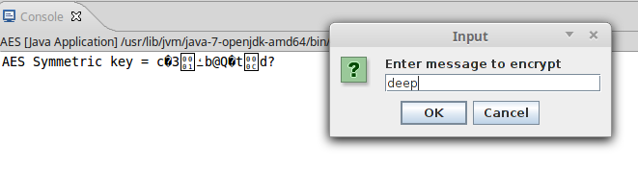

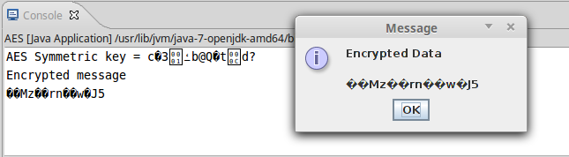

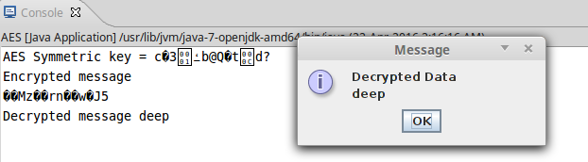

1. **Program to check primality using Miller – Rabin theorem.**

**Program:**

#include<stdio.h>

int power(int x,int y)

{

int i;

int r=1;

for(i=0;i<y;i++)

{

r=r*x;

}

return r;

}

void main(){

int n,m,i;

printf("\nenter a number");

scanf("%d",&n);

if(n%2==0)

printf("\nnumber is composite");

else{

int k=0;

m=n-1;

while(m%2==0)

{

k++;

m=m/2;

}

printf("m=%d,k=%d\n",m,k);

int intermediate,power_of_2,product;

printf("m=%dpowe=%d\n",m,power(10,m));

intermediate=power(10,m)%n;

product=intermediate*intermediate;

printf("\nintermediate=%d",intermediate);

for(i=1;i<k;i++)

{

intermediate=product%n;

printf("\nintermediate=%d",intermediate);

if(intermediate==n-1)

{

printf("\nnumber is prime\n");

break;

}

product=intermediate*intermediate;

}

if(i==k)

printf("\nnumber is composite\n");

}

}

**Output:**

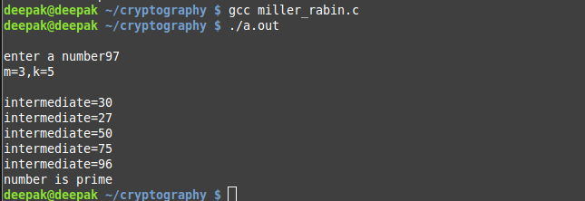

1. **Program to solve the equations using Chinese Remainder theorem.**

**Program:**

#include<stdio.h>

int power(int x,int y)

{

int i;

//printf("in power\n");

int r=1;

for(i=0;i<y;i++)

{

r=r*x;

}

return r;

}

void main(){

int n,i,x;

printf("\nenter no. of equations\n");

scanf("%d",&n);

int num1[n],mod[n],M[i],M_inverse[i];

printf("\nenter equations as--> number(mod number)\n");

for(i=0;i<n;i++)

{

scanf("%d%d",&num1[i],&mod[i]);

}

printf("\nequations are-->\n");

for(i=0;i<n;i++)

{

printf("x = %d(mod %d)\n",num1[i],mod[i]);

}

int m=1;

for(i=0;i<n;i++){

m=m*mod[i];

}

for(i=0;i<n;i++){

M[i]=m/mod[i];

}

for(i=0;i<n;i++){

M_inverse[i]=(power(M[i],mod[i]-2))%mod[i];

}

x=0;

for(i=0;i<n;i++){

x+=num1[i]*M[i]*M_inverse[i];

}

printf("\n the value of x=%d",x);

}

**Output:**

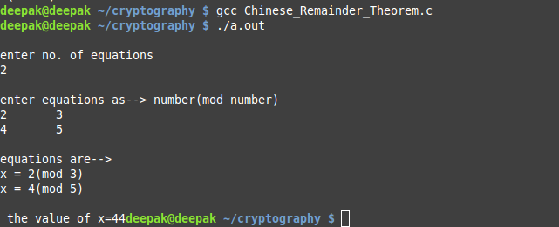

1. **Program to encrypt and decrypt the text using DES.**

**Program:**

import java.io.*;

import java.lang.*;

class SDES

{

public int K1, K2;

public static final int *P10*[] = { 3, 5, 2, 7, 4, 10, 1, 9, 8, 6};

public static final int *P10max* = 10;

public static final int *P8*[] = { 6, 3, 7, 4, 8, 5, 10, 9};

public static final int *P8max* = 10;

public static final int *P4*[] = { 2, 4, 3, 1};

public static final int *P4max* = 4;

public static final int *IP*[] = { 2, 6, 3, 1, 4, 8, 5, 7};

public static final int *IPmax* = 8;

public static final int *IPI*[] = { 4, 1, 3, 5, 7, 2, 8, 6};

public static final int *IPImax* = 8;

public static final int *EP*[] = { 4, 1, 2, 3, 2, 3, 4, 1};

public static final int *EPmax* = 4;

public static final int *S0*[][] = {{ 1, 0, 3, 2},{ 3, 2, 1, 0},{ 0, 2, 1,

3},{ 3, 1, 3, 2}};

public static final int *S1*[][] = {{ 0, 1, 2, 3},{ 2, 0, 1, 3},{ 3, 0, 1,

2},{ 2, 1, 0, 3}};

public static int permute( int x, int p[], int pmax)

{

int y = 0;

for( int i = 0; i < p.length; ++i)

{

y <<= 1;

y |= (x >> (pmax - p[i])) & 1;

}

return y;

}

public static int F( int R, int K)

{

int t = *permute*( R, *EP*, *EPmax*) ^ K;

int t0 = (t >> 4) & 0xF;

int t1 = t & 0xF;

t0 = *S0*[ ((t0 & 0x8) >> 2) | (t0 & 1) ][ (t0 >> 1) & 0x3 ];

t1 = *S1*[ ((t1 & 0x8) >> 2) | (t1 & 1) ][ (t1 >> 1) & 0x3 ];

t = *permute*( (t0 << 2) | t1, *P4*, *P4max*);

return t;

}

public static int fK( int m, int K)

{

int L = (m >> 4) & 0xF;

int R = m & 0xF;

return ((L ^ *F*(R,K)) << 4) | R;

}

public static int SW( int x)

{

return ((x & 0xF) << 4) | ((x >> 4) & 0xF);

}

public byte encrypt( int m)

{

System.*out*.println("\nEncryption Process Starts........\n\n");

m = *permute*( m, *IP*, *IPmax*);

System.*out*.print("\nAfter Permutation : ");

*printData*( m, 8);

m = *fK*( m, K1);

System.*out*.print("\nbefore Swap : ");

*printData*( m, 8);

m = *SW*( m);

System.*out*.print("\nAfter Swap : ");

*printData*( m, 8);

m = *fK*( m, K2);

System.*out*.print("\nbefore IP inverse : ");

*printData*( m, 8);

m = *permute*( m, *IPI*, *IPImax*);

return (byte) m;

}

public byte decrypt( int m)

{

System.*out*.println("\nDecryption Process Starts........\n\n");

*printData*( m, 8);

m = *permute*( m, *IP*, *IPmax*);

System.*out*.print("\nAfter Permutation : ");

*printData*( m, 8);

m = *fK*( m, K2);

System.*out*.print("\nbefore Swap : ");

*printData*( m, 8);

m = *SW*( m);

System.*out*.print("\nAfter Swap : ");

*printData*( m, 8);

m = *fK*( m, K1);

System.*out*.print("\nBefore Extraction Permutation : ");

*printData*( m, 4);

m = *permute*( m, *IPI*, *IPImax*);

System.*out*.print("\nAfter Extraction Permutation : ");

*printData*( m, 8);

return (byte) m;

}

public static void printData( int x, int n)

{

int mask = 1 << (n-1);

while( mask > 0)

{

System.*out*.print( ((x & mask) == 0) ? '0' : '1');

mask >>= 1;

}

}

public SDES( int K)

{

K = *permute*( K, *P10*, *P10max*);

int t1 = (K >> 5) & 0x1F;

int t2 = K & 0x1F;

t1 = ((t1 & 0xF) << 1) | ((t1 & 0x10) >> 4);

t2 = ((t2 & 0xF) << 1) | ((t2 & 0x10) >> 4);

K1 = *permute*( (t1 << 5)| t2, *P8*, *P8max*);

t1 = ((t1 & 0x7) << 2) | ((t1 & 0x18) >> 3);

t2 = ((t2 & 0x7) << 2) | ((t2 & 0x18) >> 3);

K2 = *permute*( (t1 << 5)| t2, *P8*, *P8max*);

}

public static void main( String args[]) throws Exception

{

DataInputStream inp=new DataInputStream(System.*in*);

System.*out*.println("Enter the 10 Bit Key :");

int K = Integer.*parseInt*(inp.~~readLine~~(),2);

SDES A = new SDES( K);

System.*out*.println("Enter the 8 Bit message To be Encrypt : ");

int m = Integer.*parseInt*(inp.~~readLine~~(),2);

System.*out*.print("\nKey K1: ");

SDES.*printData*( A.K1, 8);

System.*out*.print("\nKey K2: ");

SDES.*printData*( A.K2, 8);

m = A.encrypt( m);

System.*out*.print("\nEncrypted Message: ");

SDES.*printData*( m, 8);

m = A.decrypt( m);

System.*out*.print("\nDecrypted Message: ");

SDES.*printData*( m, 8);

} }

**Output:**

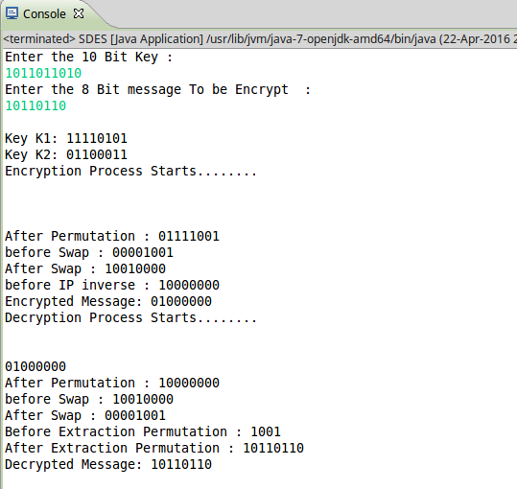

1. **Program to implement fast exponentiation.**

**Program:**

#include<stdio.h>

long squareOfMultiply(long a,long x,long n){

int i,k=0;

long y=1,t,binary[100];

long num=x;

while(num!=0)

{

binary[k]=num%2;

k++;

num=num/2;

}

for(i=0;i<k;i++)

{

if(binary[i]==1){

y=(a*y)%n;

a=(a*a)%n;

}

else

{

a=(a*a)%n;

}

}

return y;

}

void main(){

long a,m,n;

printf("enter value of a,m and n in-------> a^m mod n");

scanf("%ld %ld %ld",&a,&m,&n);

long s=squareOfMultiply(a,m,n);

printf("\nvalue of a^m mod n = %ld",s);

}

**Output:**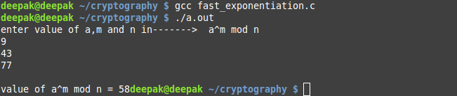

1. **Program to implement RSA algorithm.**

**Program:**

#include<stdio.h>

int power(int x,int y)

{

int i;

//printf("in power\n");

int r=1;

for(i=0;i<y;i++)

{

r=r*x;

}

return r;

}

int bits(int x)

{

int s=0;

while(x)

{

x=x/10;

s++;

}

return s;

}

int squareOfMultiply(int a,int x,int n)

{

int i,k=0,y=1,t,binary[100];

int num=x;

while(num!=0)

{

binary[k]=num%2;

//r=r+t*power(10,i);

k++;

num=num/2;

}

//printf("\nBinary of x\n");

for(i=0;i<k;i++)

{

//printf("%d ",binary[i] );

}

//printf("\nx=%d,bits=%d\n",x,k);

for(i=0;i<k;i++)

{

if(binary[i]==1){

y=(a*y)%n;

a=(a*a)%n;

//printf("\nhere---i=%d,binary[i]=%d,y=%d,a=%d\n",i,binary[i],y,a );

}

else

{

a=(a*a)%n;

//printf("\ni=%d,binary[i]=%d,y=%d,a=%d\n",i,binary[i],y,a );

}

}

return y;

//printf("\ny=%d",y);

}

void main()

{

//printf("Enter (a,x,n) ----->a^x mod n\n");

//int a=17,x=22,n=21;

//printf("\n Entered value is---> %d^%d mod %d",a,x,n);

//int y=squareOfMultiply(a,x,n);

//printf("y=%d\n",y);

int p=7,q=11;

//printf("\nenter any two prime numbers p and q where p!=q");

//scanf("%d%d",&p,&q);

printf("\nvalue of p=%d,q=%d",p,q);

int n=p*q;

int phi_of_n=(p-1)*(q-1);

printf("\nphi(n)=%d",phi_of_n);

int e=13;

//int d=(power(e,phi_of_n-2))%phi_of_n;

int d=37;

printf("\nd=%d",d);

int PT=5;

//printf("\nEnter thePlainText");

//scanf("%d",PT);

printf("\nEntered value is---> %d^%d mod %d",PT,e,n);

int y=squareOfMultiply(PT,e,n);

printf("\ny=%d\n",y);

}

**Output:**

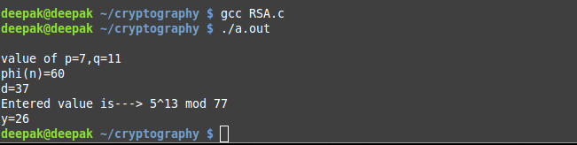

1. **Program to implement text cover.**

**Program:**

**package** servlet;

**import** java.util.Scanner;

**public** **class** textcipher {

**public** **static** **void** main(String args[])

{//Input the text that has to be encrypted

Scanner obj=**new** Scanner(System.***in***);

String Key="AOHIT";String bin="";String fin="";**int** h;

**char** c[]=Key.toCharArray();

**int** l=Key.length();

**char** ch;**int** conv;

**for**(**int** i=0;i<l;i++){

ch=c[i];

conv=(**int**)ch;

**while**(conv>=1){

h=conv%2;

conv=conv/2;

bin=bin+h;

}

}

System.***out***.println(bin);

**int** k=bin.length();

**char** d[]=bin.toCharArray();

String enc="a";

**for**(**int** j=0;j<k;j++){

**if**(d[j]=='1')

enc=enc+" a";

**else**

enc=enc+" bd";

}

System.***out***.println(enc);

}}

**Output:**

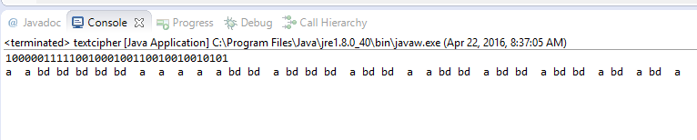

1. **Program to implement random number generator.**

**Program:**

#include <stdio.h>

int jsw_lcg(int seed)

{

return (2 * seed + 3) % 10;

}

int main(void)

{

int seed;

int i;

printf("\nEnter seed value");

scanf("%d",&seed);

for (i = 0; i < 10; i++)

{

printf("%d ", seed);

seed = jsw_lcg(seed);

}

printf("...\n");

return 0;

}

**Output:**

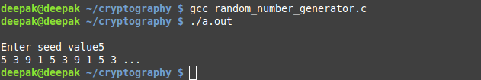

1. **Program to implement Discrete algorithm.**

**Program**:

import java.math.BigInteger;

import java.util.HashMap;

import java.util.Map;

public class Main {

//sample numbers. Note we MUST use BigIntegers

static BigInteger *h* = new BigInteger("3239475104050450443565264378728065788649097520952449527834792452971981976143292558073856937958553180532878928001494706097394108577585732452307673444020333");

static BigInteger *g* = new BigInteger("11717829880366207009516117596335367088558084999998952205599979459063929499736583746670572176471460312928594829675428279466566527115212748467589894601965568");

static BigInteger *p* = new BigInteger("13407807929942597099574024998205846127479365820592393377723561443721764030073546976801874298166903427690031858186486050853753882811946569946433649006084171");

static long *B* = 1048576;//2^20

//build hashtable of all possible h/(g^x1) for x1 in 0..B

private static Map<BigInteger, Long> leftHash(){

Map<BigInteger, Long> m = new HashMap<BigInteger, Long>();

BigInteger n, gpow, ginversepow;

for(long i=0; i<*B*; i++){

//compute g^x1 mod p

gpow = *g*.modPow(new BigInteger(i+""), *p*);

//compute 1/(g^x1) mod p

ginversepow = gpow.modInverse(*p*);

//compute h/(g^x1) mod p

n = *h*.multiply(ginversepow);

n = n.mod(*p*);

//store in hashtable

m.put(n, i);

}

System.*out*.println("Hashtable done");

return m;

}

//compute n = g^B^x0 for x0 in 0..B, then check if n is in hashtable. If it is, we found (x0, x1) and can compute x as x0*B+x1

private static long computeDiscreteLog(Map<BigInteger, Long> m){

BigInteger n;

long res = 0;

//compute g^B

BigInteger gB = *g*.modPow(new BigInteger(*B*+""), *p*);

for(long i=0; i<*B*; i++){

//compute g^B^x0

n = gB.modPow(new BigInteger(i+""), *p*);

if(m.containsKey(n)){

res = i\**B*+m.get(n);

break;

}

}

return res;

}

public static void main(String [] args){

Map<BigInteger, Long> m = *leftHash*();

long res = *computeDiscreteLog*(m);

System.*out*.println("Found "+res);

}

}

**Output:**

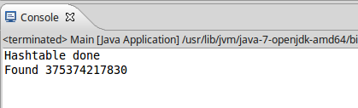

1. **Program to implement DSA algorithm.**

**Program:**

#include<stdio.h>

long power(long x,long y)

{

int i;

long r=1;

for(i=0;i<y;i++)

{

r=r*x;

}

return r;

}

int modInverse(int a, int m)

{

int m0 = m, t, q;

int x0 = 0, x1 = 1;

if (m == 1)

return 0;

while (a > 1)

{

// q is quotient

q = a / m;

t = m;

// m is remainder now, process same as

// Euclid's algo

m = a % m, a = t;

t = x0;

x0 = x1 - q * x0;

x1 = t;

}

// Make x1 positive

if (x1 < 0)

x1 += m0;

return x1;

}

long squareOfMultiply(long a,long x,long n)

{

int i,k=0;

long y=1,t,binary[100];

long num=x;

while(num!=0)

{

binary[k]=num%2;

k++;

num=num/2;

}

for(i=0;i<k;i++)

{

if(binary[i]==1){

y=(a*y)%n;

a=(a*a)%n;

}

else

{

a=(a*a)%n;

}

}

return y;

}

long m=1;

long mod(long a, long n){

if(a>0){

return a%n;

}

else{

a=a+m*n;

m++;

if(a<0) mod(a,n);

else return a;

}

}

void main(){

long p=23,q=11,a=5,g=2,d=8,h=12,k=5;

long g_pow_d=squareOfMultiply(g,d,p);

printf("\n----------------------Alice Key Generation--------------------");

printf("\nAlice public key (p,q,g,g_pow_d) = (%ld,%ld,%ld,%ld)",p,q,g,g_pow_d);

printf("\n----------------------Signing by Alice----------------------------");

long r=squareOfMultiply(g,k,p);

r=r%q;

long s=(h+d*r);

long x=modInverse(k,q);

s=(s*x)%q;

printf("\n value of r=%ld s=%ld",r,s);

printf("\n---------------------Verification by Bob------------------------");

x=modInverse(s,q);

long u1=(h*x)%q;

long u2=(r*x)%q;

printf("\nvalue of u1=%ld u2=%ld",u1,u2);

x=power(g,u1)%p;

long y=power(g_pow_d,u2)%p;

x=(x*y)%p;

long v=x%q;

printf("\nvalue of v=%ld\n",v);

}

**Output:**

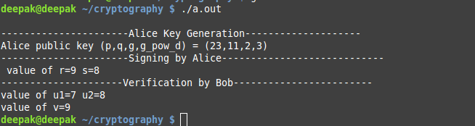

1. **Program to implement Elgamal DSA.**

**Program:**

#include<stdio.h>

long t1=0,t2=1,r,q,t;

long squareOfMultiply(long a,long x,long n)

{

int i,k=0;

long y=1,t,binary[100];

long num=x;

while(num!=0)

{

binary[k]=num%2;

k++;

num=num/2;

}

for(i=0;i<k;i++)

{

if(binary[i]==1){

y=(a*y)%n;

a=(a*a)%n;

}

else

{

a=(a*a)%n;

}

}

return y;

}

long reverse(long r1,long r2){

if(r1<=1)

return t1;

else

{

//printf("\nvalue of r=%ld, q=%ld, r1=%ld, r2=%ld, t=%ld, t1=%ld, t2=%ld",r,q,r1,r2,t,t1,t2);

r=r1%r2;

q=r1/r2;

r1=r2;

r2=r;

t=t1-t2*q;

t1=t2;

t2=t;

reverse(r1,r2);

}

}

long m=1;

long mod(long a, long n){

if(a>0){

return a%n;

}

else{

a=a+m*n;

m++;

if(a<0) mod(a,n);

else return a;

}

}

long power(long x,long y)

{

long i;

//printf("in power\n");

long r=1;

for(i=0;i<y;i++)

{

r=r*x;

}

return r;

}

void main(){

long p=23,g=5,d=3,k=9,h=7;

long g_pow_d=squareOfMultiply(g,d,p);

printf("\n-----------Key Generation-----------");

printf("\nPublic Key (p,g,g_pow_d) = (%ld,%ld,%ld)",p,g,g_pow_d);

printf("\n-----------Signing------------------");

long r=squareOfMultiply(g,k,p);

long x=reverse(p-1,k);

x=(h-d*r)*x;

long s=mod(x,p-1);

printf("\nvalue of (r,s) = (%ld,%ld)",r,s);

printf("\n---------Verification--------------");

long v1=squareOfMultiply(g,h,p);

x=power(g_pow_d,r);

x=power(r,s)*x;

long v2=mod(x,p);

printf("\nvalue of (v1,v2) = (%ld,%ld)\n",v1,v2);

}

**Output:**

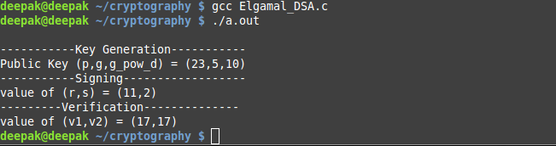

1. **Program to implement RSA DSA.**

**Program:**

#include<stdio.h>

long t1=0,t2=1,r,q,t;

long reverse(long r1,long r2){

if(r1<=1)

return t1;

else

{

//printf("\nvalue of r=%ld, q=%ld, r1=%ld, r2=%ld, t=%ld, t1=%ld, t2=%ld",r,q,r1,r2,t,t1,t2);

r=r1%r2;

q=r1/r2;

r1=r2;

r2=r;

t=t1-t2*q;

t1=t2;

t2=t;

reverse(r1,r2);

}

}

long squareOfMultiply(long a,long x,long n)

{

int i,k=0;

long y=1,t,binary[100];

long num=x;

while(num!=0)

{

binary[k]=num%2;

k++;

num=num/2;

}

for(i=0;i<k;i++)

{

if(binary[i]==1){

y=(a*y)%n;

a=(a*a)%n;

}

else

{

a=(a*a)%n;

}

}

return y;

}

void main(){

long p=7,q=11,e=7,m=9;

long n=p*q;

long phi=(p-1)*(q-1);

long d;

long k=reverse(phi,e);

if(k<0) d=k+phi;

//printf("\nphi=%ld e=%ld",phi,e);

printf("\n-------Key generation-------");

printf("\npublic key------>(e,n)=(%ld,%ld)",e,n);

printf("\nprivate key------>(d,n)=(%ld,%ld)",d,n);

printf("\n-------Signing---------");

long s=squareOfMultiply(m,d,n);

printf("\nsignature s=%ld",s);

printf("\n------Verification------");

long x=squareOfMultiply(s,e,n);

printf("\n value of x=%ld\n",x);

}

**Output:**

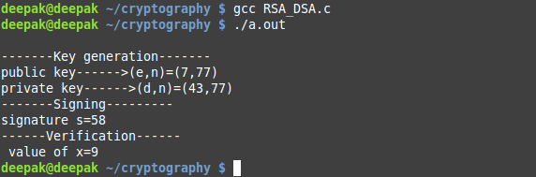

1. **Program to implement Diffie Hellman algorithm.**

**Program:**

#include<stdio.h>

long squareOfMultiply(long a,long x,long n)

{

int i,k=0;

long y=1,t,binary[100];

long num=x;

while(num!=0)

{

binary[k]=num%2;

k++;

num=num/2;

}

for(i=0;i<k;i++)

{

if(binary[i]==1){

y=(a*y)%n;

a=(a*a)%n;

}

else

{

a=(a*a)%n;

}

}

return y;

}

void main(){

long g=7,p=23,x=3,y=6;

printf("\nValue of g=%ld, p=%ld",g,p);

printf("\n----------Alice calcutes R1-----------");

long R1=squareOfMultiply(g,x,p);

printf("\nx=%ld , R1=%ld",x,R1);

printf("\n----------Bob calcutes R2-------------");

long R2=squareOfMultiply(g,y,p);

printf("\ny=%ld , R2=%ld",y,R2);

printf("\nAlice sends R1 = %ld to Bob",R1);

printf("\nBob sends R2 = %ld to Alice",R2);

printf("\n-----------Verification--------------");

long k=squareOfMultiply(R2,x,p);

printf("\nAlice calculates k = %ld",k);

k=squareOfMultiply(R1,y,p);

printf("\nBob calculates k = %ld\n",k);

}

**Output:**

